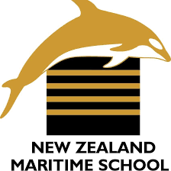


NEW ZEALAND MARITIME SCHOOL
NZ Diploma in Marine Electro-technology (NZ2894)
(STCW 1978 A-III/6, as amended in 2010)
Electro-Technical Officer, Year 2 Cadets, 2020.

Course Code
942.637 - AS01.

Course Title
Marine Computer Networks Learning Outcomes Assessment.

Tutor
Mike Huggis
Nick Cossar

Student Name: Levi Dubbelman

Student ID: 190000929

Date: 27/08/2020

Describe the purpose and structure of a typical Marine network for process control.
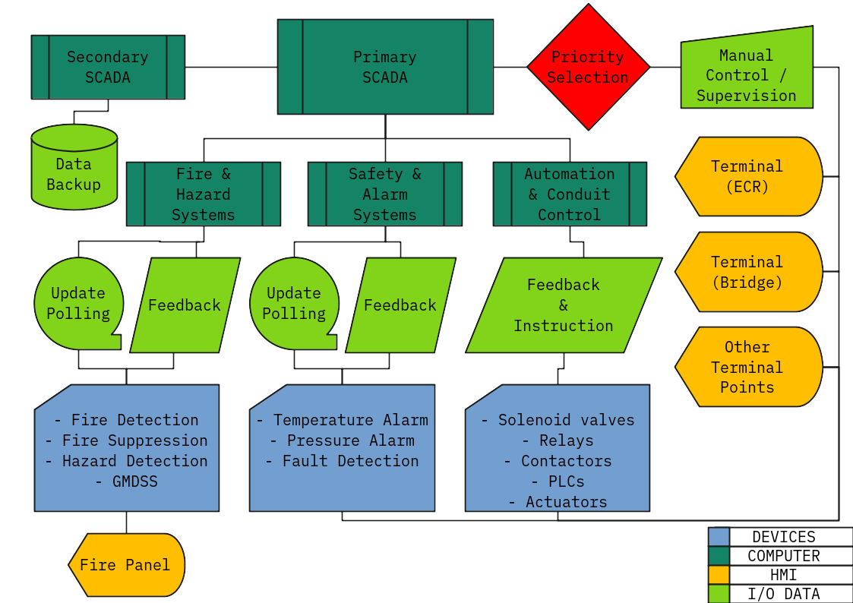

Process control systems in marine environments utilize a top-down hierarchy, and centralized command structure architecture comprising of computers, networked data communicators and human-machine interfaces (HMI/GUI).
For high-level process supervision, referred to as supervisory control and data acquisition (SCADA), a central computer system sends and receives data and instructions to all other networked components. This system is capable of automated process control, such as the purification of heavy fuel oils (HFO) with no direct interaction from crew.
Despite this, direct interaction and supervision of the system is achieved through human-machine interfaces (HMI) systems present in several distinct locations throughout the vessel, and potentially on-shore, although this is not yet commonplace.
These points of interaction, often referred to as “terminals”, are placed strategically in areas where technical crew are able to perform watchkeeping duties over the vessel during normal operation. When paired with a rigorous preventative maintenance schedule, and consistent and thorough watchkeeping practices, this system is capable of continuous, uninterrupted vessel operation for greatly extended periods of time, potentially even years.
On the lower level of the hierarchy, devices such as programmable logic controllers (PLCs) are able to directly control solenoid valves or circuit breakers to allow hands-free operation of virtually any mechanical or electro-mechanical device required to perform specific tasks. An example of this would be an elevator system, controlling a brake, counterweight, variable speed drive (and its attached motor) as well as dozens, if not hundreds, of limit switches and performing calculations for velocity, excessive load and over-travel to pass to an alarm monitoring system higher up in the hierarchy.

Describe serial transmission the following data buses, RS 232, RS 422, RS 485.

Describe cable connectors and terminators for RS 232, RS 422, RS 485.
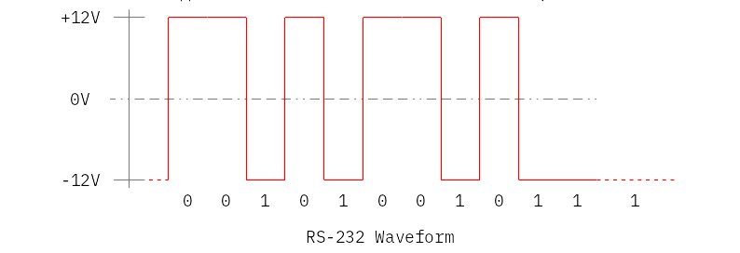

RS-232
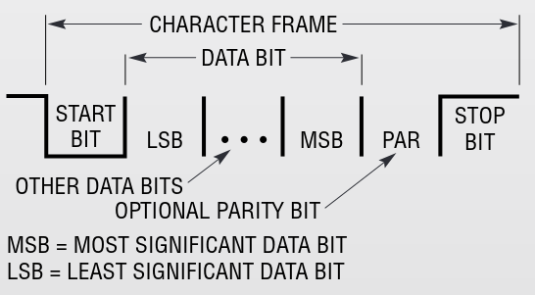

RS-232 conveys data over a simple non-terminated, multi-conductor cable at rates up to 20kB. The RS-232 standard specifies the electrical characteristics and connector for an all encompassing point-to-point modem interface. Although the original specification was intended for modems, subsequent renderings shed unneeded signals to expand its scope and use as a general purpose serial interface at data rates up to 1MB.
Source: https://www.analog.com/media/en/technical-documentation/product-selector-card/rs232%20quick%20guide.pdf
The signal transmission character frame of RS-232 includes a start bit followed by the LSB to MSB with an optional parity bit, before the stop bit.
Because RS-232 is used beyond the original purpose of interconnecting a terminal with a modem, successor standards have been developed to address the limitations. Issues with the RS-232 standard include:
- The large voltage swings and requirement for positive and negative supplies increases power consumption of the interface and complicates power supply design. The voltage swing requirement also limits the upper speed of a compatible interface.
- Single-ended signaling referred to a common signal ground limits the noise immunity and transmission distance.
- Multi-drop connection among more than two devices is not defined. While multi-drop "work-arounds" have been devised, they have limitations in speed and compatibility.
- The standard does not address the possibility of connecting a DTE directly to a DTE, or a DCE to a DCE. Null modem cables can be used to achieve these connections, but these are not defined by the standard, and some such cables use different connections than others.
- The definitions of the two ends of the link are asymmetric. This makes the assignment of the role of a newly developed device problematic; the designer must decide on either a DTE-like or DCE-like interface and which connector pin assignments to use.
- The handshaking and control lines of the interface are intended for the setup and takedown of a dial-up communication circuit; in particular, the use of handshake lines for flow control is not reliably implemented in many devices.
- No method is specified for sending power to a device. While a small amount of current can be extracted from the DTR and RTS lines, this is only suitable for low-power devices such as mice.
- The 25-pin D-sub connector recommended in the standard is large compared to current practice.
Source: https://en.wikipedia.org/wiki/RS-232#cite_note-7
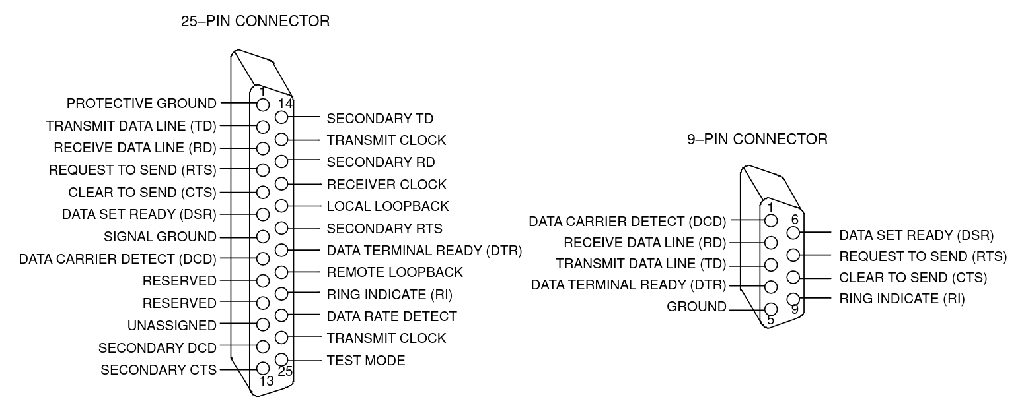
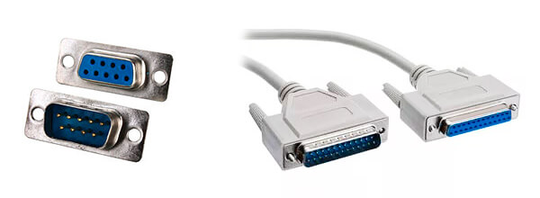
Source: https://www.lammertbies.nl/download/dallas-appl-83.pdf

RS-422 and RS-485
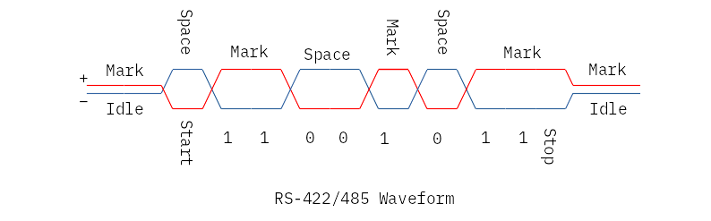
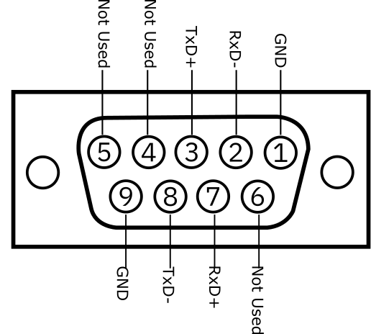
DB9 Layout for RS-422 / 485
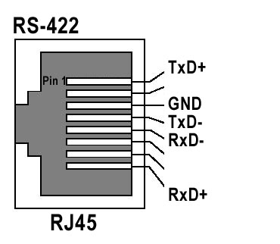
RJ-45 Layout for RS-422 / 485
RS-422 and RS-485 are physically similar standards by the EIA. The former is known as TIA/EIA-422, while the latter is known as TIA-485(-A) or EIA-485.
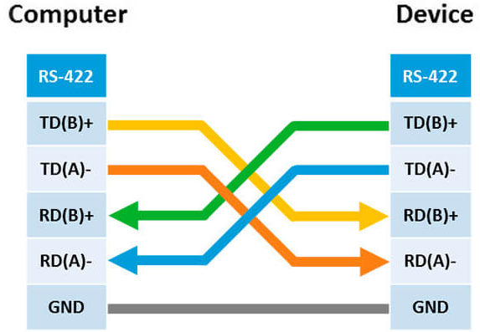

The key difference between the two is that while RS-422 may only handle point-to-point communications, RS-485’s topology is able to communicate with multiple points, allowing the connection of multiple senders and receivers. This advantage makes it the most common standard used in the industry.
Furthermore, in half-duplex mode (RS-485) is able to send or receive, while in full duplex mode it is able to send and receive simultaneously.
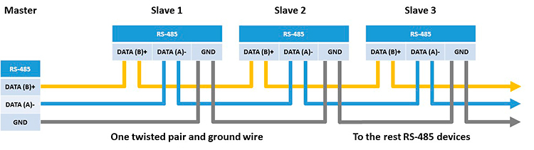
Source: https://expertdaq.com/en/faq/difference-between-rs422-and-rs485-bus/
 | RS-232 | RS-422 | RS-485
Transfer type | Full Duplex | Full Duplex | Half (2) and Full (4)
Maximum Distance | 15m @ 9600bps | 1200m @ 9600bps | 1200m @ 9600bps
Contacts in Use | TxD, RxD, RTS, CTS, DTR, DSR, DCD, GND* | TxA, TxB, RxA, RxB, GND | DataA, DataB, GND
Topology | Point-to-Point | Point-to-Point | Multi-point
Max # of Devices | 1 | 1 (10 devices in receive mode) | 32 (repeaters may handle up to 256)
*For the RS-232 interface, it is not necessary to use all contact lines. Typically, TxD, RxD and GND ground lines are used
Source: https://ipc2u.com/articles/knowledge-base/the-main-differences-between-rs-232-rs-422-and-rs-485/

Describe Ethernet protocols: OSI/ISO, TCP/IP.
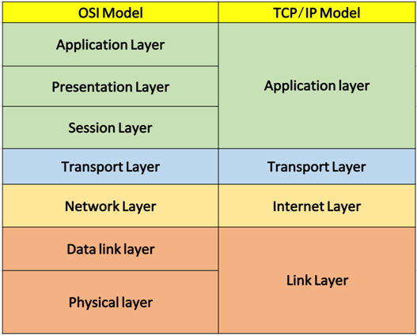

TCP/IP

TCP (Transmission Control Protocol) over IP (Internet Protocol) was developed by Defense Advanced Research Projects Agency (DARPA). Unlike the OSI Model, it consists of four layers each having its own protocols. Internet Protocols are the set of rules defined for communication over the network.
TCP/IP is considered as the standard protocol model for networking. TCP handles data transmission and IP handles addresses. The TCP/IP protocol suite has a set of protocols that includes TCP, UDP, ARP, DNS, HTTP, ICMP, etc. It is a robust and flexible model. The TCP/IP model is mostly used for interconnecting computers over the internet.

The 4 key layers of TCP/IP are as follows:
- Network Interface Layer: This layer acts as an interface between hosts and transmission links and used for transmitting datagrams. It also specifies what operation must be performed by links like serial link and classic ethernet to fulfil the requirements of the connectionless internet layer.
- Internet Layer: The purpose of this layer is to transmit an independent packet into any network which travels to the destination (might be residing in a different network). It includes the IP (Internet Protocol), ICMP (Internet Control Message Protocol) and ARP (Address Resolution Protocol) as the standard packet format for the layer.
- Transport Layer: It enables a fault-free end-to-end delivery of the data between the source and destination hosts in the form of datagrams. The protocols defined by this layer are TCP (Transmission Control Protocol) and UDP (User Datagram Protocol).
- Application Layer: This layer permits users to access the services of global or private internet. The various protocols described in this layer are virtual terminal (TELNET), electronic mail (SMTP) and file transfer (FTP). Some additional protocols like DNS (Domain Name System), HTTP (Hypertext Transfer Protocol) and RTP (Real-time Transport Protocol). The working of this layer is a combination of application, presentation and session layer of the OSI model.
Source: https://techdifferences.com/difference-between-tcp-ip-and-osi-model.html

Advantages of TCP/IP
- It helps you to establish/set up a connection between different types of computers.
- It operates independently of the operating system.
- It supports many routing-protocols.
- It enables the internetworking between the organizations.
- TCP/IP model has a highly scalable client-server architecture.
- It can be operated independently.
- Supports several routing protocols.
- It can be used to establish a connection between two computers.

Disadvantages of TCP/IP
- TCP/IP is a complicated model to set up and manage.
- The shallow/overhead of TCP/IP is higher-than IPX (Internetwork Packet Exchange).
- In this, model the transport layer does not guarantee delivery of packets.
- Replacing protocol in TCP/IP is not easy.
- It has no clear separation from its services, interfaces, and protocols.
Source: https://www.guru99.com/difference-tcp-ip-vs-osi-model.html
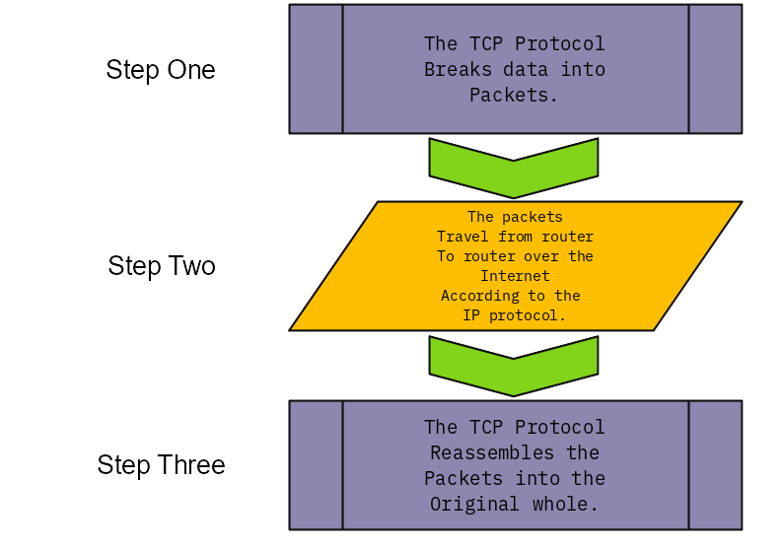

OSI/ISO

OSI (Open System Interconnection) model was introduced by the International Standard Organization (ISO). It is not a protocol, but rather a model which is based on the concept of layering. It has a vertical set of layers, each having different functions. It follows a bottom-up approach to transfer the data. It is robust and flexible, but not tangible.
The main intent of OSI reference model is to conduct the designing and development of the digital communication hardware, devices and software in a way that they can efficiently interoperate.

The seven layers of OSI model are as follows:
- Application Layer: With this layer, the users can access the network by using interfaces and services like electronic mail, shared database management, file access/transfer and the other services.
- Presentation Layer: Presentation layer focuses on the syntax and semantics of the transmitting information. It performs tasks such as translation, encryption and compression where the actual information existing in the form of character strings, numbers, symbols is encoded into bit streams, converted into another form and compressed.
- Session Layer: This layer establishes the session between different machines in order to synchronize and maintain the interaction between them. The services provided by the session layer are dialog control, token management and synchronization.
- Transport Layer: It accepts the data from its preceding layer in the form of independent packets and transmits it to the succeeding layer in proper order. The other function carried out by this layer are service point addressing, connection control, segmentation and reassembly, flow control and error control.
- Network Layer: Logical addressing and routing are the major operations performed by the network layer. It translates the network logical address into physical MAC address so that the two systems residing in the different networks could also communicate efficiently. A packet also requires a path to be followed to reach at the destination avoiding congestion and failed components, so it also facilitates the automatic updation of the routes.
- Data Link Layer: It is responsible for transforming the raw transmission service (Physical layer) into a reliable link. It makes the physical layer free from error by masking them so that the network layer does not notice them. In this layer, the input data is split into frames. The tasks carried out in the data link layer are framing, access control, physical addressing, error and flow control.
- Physical Layer: It transmits the individual bits over the transmission channel. The physical layer deals with the description of the characteristics of the interface between the devices and the transmission media, representation of bits, synchronization of the bits, data rate, physical topology, line configuration, transmission mode.
Source: https://techdifferences.com/difference-between-tcp-ip-and-osi-model.html

Advantages of the OSI Model
- It helps you to standardize router, switch, motherboard, and other hardware
- Reduces complexity and standardizes interfaces
- Facilitates modular engineering
- Helps you to ensure interoperable technology
- Helps you to accelerate the evolution
- Protocols can be replaced by new protocols when technology changes.
- Provide support for connection-oriented services as well as connectionless service.
- It is a standard model in computer networking.
- Supports connectionless and connection-oriented services.
- It offers flexibility to adapt to various types of protocols.

Disadvantages of OSI Model
- Fitting of protocols is a tedious task.
- You can only use it as a reference model.
- It doesn't define any specific protocol.
- In the OSI network layer model, some services are duplicated in many layers such as the transport and data link layers
- Layers can't work in parallel as each layer need to wait to obtain data from the previous layer.
Source: https://www.guru99.com/difference-tcp-ip-vs-osi-model.html

Explain - master-slave, master-slave with cyclical poling, token ring, token ring with master-slave polling, CSMA/CD, CSMA/CA.

Token Ring
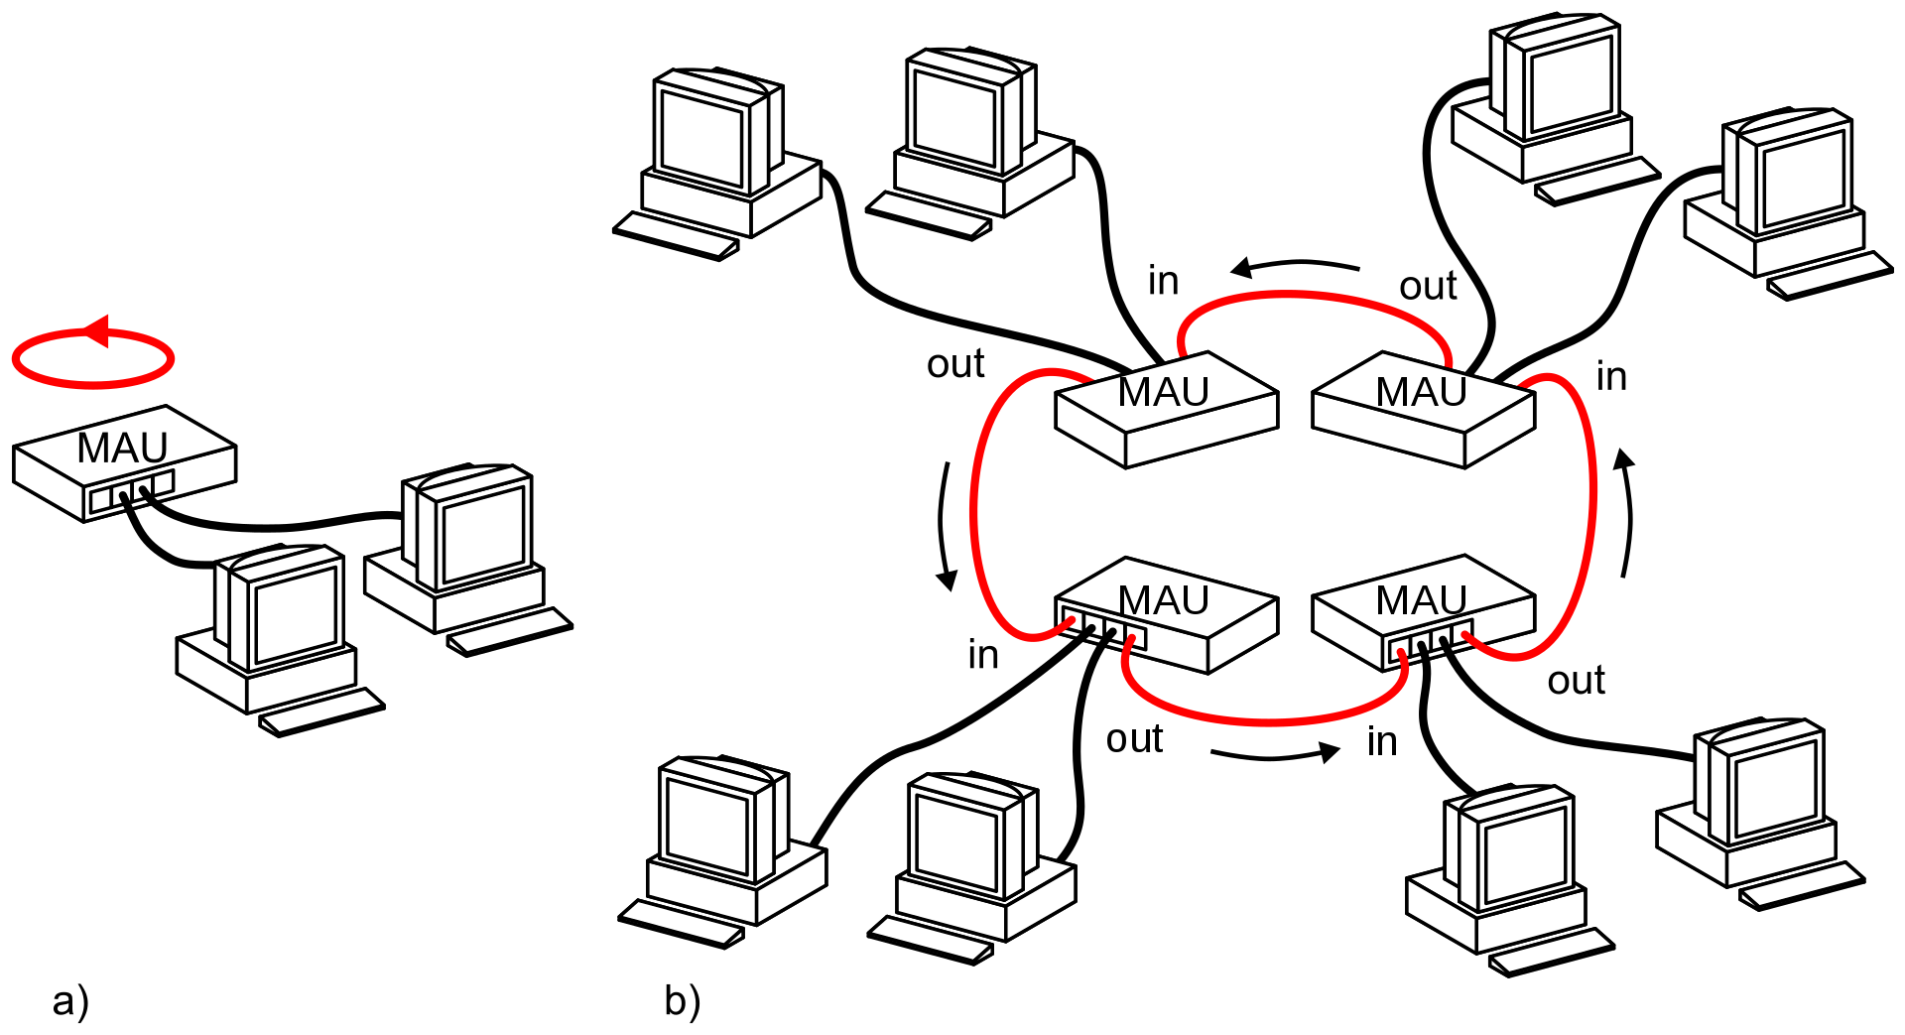

Token Ring with a singular Media Access Unit (MAU) vs b) Multiple MAUs
Token Ring is a computer networking technology used to build local area networks. It uses a special three-byte frame called a token that travels around a logical ring of workstations or servers. This token passing is a channel access method providing fair access for all stations, and eliminating the collisions of contention-based access methods.
Source: https://en.wikipedia.org/wiki/Token_ring
By passing data sequentially throughout the ring, as long as the network is not excessively overloaded with devices, there is very little congestion and collision, making it ideal for corporate local area networks for up to 255 devices. Although today, most networks have migrated to ethernet.
Source: https://www.techopedia.com/definition/26095/token-ring-network
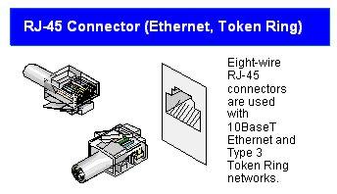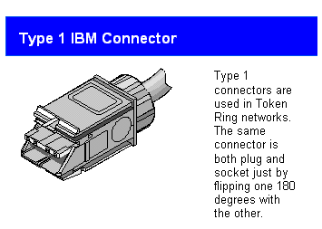

Master/Slave Polling
In a master/slave relationship, only one device, the master, has the right to initiate a communication cycle. This ensures that two devices can never access the network at the same time. All other devices, the slaves, transmit only when requested by the master.
Usually, the master employs the polling method, servicing the slaves one after the other in a cyclic manner. Messages with high priority are polled repeatedly within a cycle.Slave devices are frequently low-maintenance field devices, such as sensors, control valves and transducers.
Normally, the slaves cannot communicate directly with each other. The data is read by the master and forwarded as required. However, it is possible to address a transmitter and a recipient slave at the same time, thereby initiating direct data exchange.
The master/slave control is a simple and cost-effective method as only one station must assume the complex task of controlling the network. As far as the slave participants are concerned, only part of the protocol needs to be implemented. However, a defective master causes the entire network to fail. This can be avoided when a slave is configured to assume the functions of the master.
The distributed access assignment according to the token passing method does not require a single participant to be so reliable and available. All the network participants are able to assume the functions of a master.
The master functions are assigned to the communication participants in a prescribed order. This is done by passing a special message, the token, from one active participant to the next within a logical ring. The participant which presently has the token is the network master having sole control over the network.
When a time span defined by the token rotation cycle is over, the token must be passed on to the next active participant.
Source: https://www.samsongroup.com/document/l155en.pdf Page 14-15

CSMA/CD & CSMA/CA
Carrier Sense Multiple Access / Collision Avoidance and / Collision Detection are network protocols for carrier transmission. By “sensing” the state of the bus, CSMA/CA and CSMA/CD are able to preventing the transmission of signals until the bus is available.
The key difference is that CSMA/CD is reactive, while CSMA/CA is preventative. CSMA/CD will immediately cease transmission upon detection of a collision, while CSMA/CA will actively prevent a collision event. The downside is efficiency.
CSMA/CD | CSMA/CA
Only effective after a collision event. | Effective prior to a collision event.
Exclusively used in wired networks. | Most commonly used in wireless networks.
Reduces the recovery time. | Minimizes the possibility of a collision.
Resends the data frame when a collision occurs. | Firstly transmits the intent to resend the data frame.
802.3 Standard | 802.11 Standard
More efficient than simple CSMA | Similar to CSMA
Source: https://www.geeksforgeeks.org/difference-between-csma-ca-and-csma-cd/

Describe PROFIBUS and PROFINET networks, as used in a marine installation.
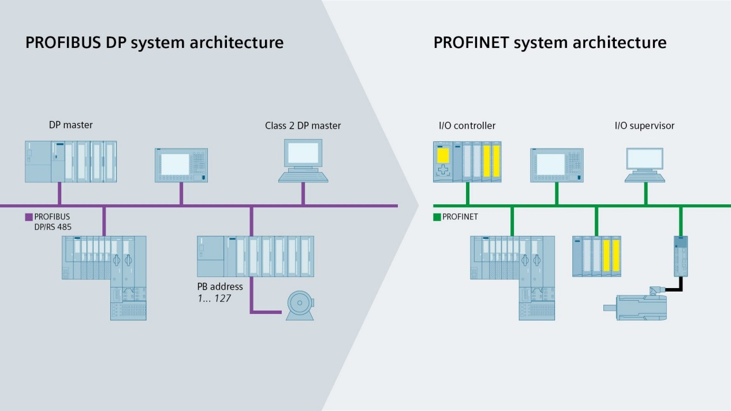

PROFINET is the communication standard for automation from PROFIBUS & PROFINET International (PI). PROFINET follows the provider/consumer model for data exchange. This means that both the IO controller and IO device spontaneously send cyclic data independently.
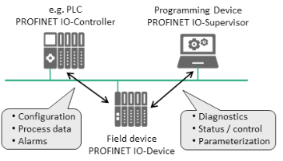
A standard PROFINET configuration typically includes the following:
IO controller: This is typically the Programmable Logic Controller (PLC) in which the automation program runs. The IO controller provides output data to the configured IO devices in its role as provider and is the consumer of input data.
IO device: An IO device is a distributed IO field device connected to one or more IO controllers via PROFINET. The IO device is the provider of input data and the consumer of output data from the IO controller.
IO supervisor: This can be a programming device (PG), personal computer or human machine interface (HMI) device for commissioning or diagnostic purposes. A system unit contains at least one IO controller and one or more IO devices. IO supervisors are usually integrated only temporarily for commissioning or troubleshooting purposes.
PROFINET specifies a model for integrating existing PROFIBUS systems and other fieldbus systems such as INTERBUS and DeviceNet. This means that any combination of fieldbus and PROFINET-based systems can be configured.
Source: https://profibus.com/index.php?eID=dumpFile&t=f&f=82430&token=7cbb78f5ba6b3e17762ab594f803f1901eb24fdf

Describe Industrial Ethernet network, as used in a marine installation.

Ethernet is a well known and recognized technology in the home and office environment. Recently, it has become standardized and additionally redundant so that it might be applied successfully and safely to a marine environment. The network works well because it uses "handshaking" to ensure message delivery.
A handshake is an automated process of negotiation between two participants, through the exchange of information that establishes the protocols of a communication link at the start of the communication, before full communication begins. In an Industrial Ethernet scenario, a handshake tells the sender of the information that the recipient has successfully received the packet. This is vital, as it ensures that every aspect of the automation process has up-to-date and correct information.
In an Industrial Ethernet network, we also incorporate collision detection. If two messages collide in the network, the controlling PLC can resend the message to the device until it receives a delivery notice for the device. These transactions occur over just a few milliseconds. Which may reduce overall message efficiency, in automation in industrial environments, it's better to be safe than sorry.
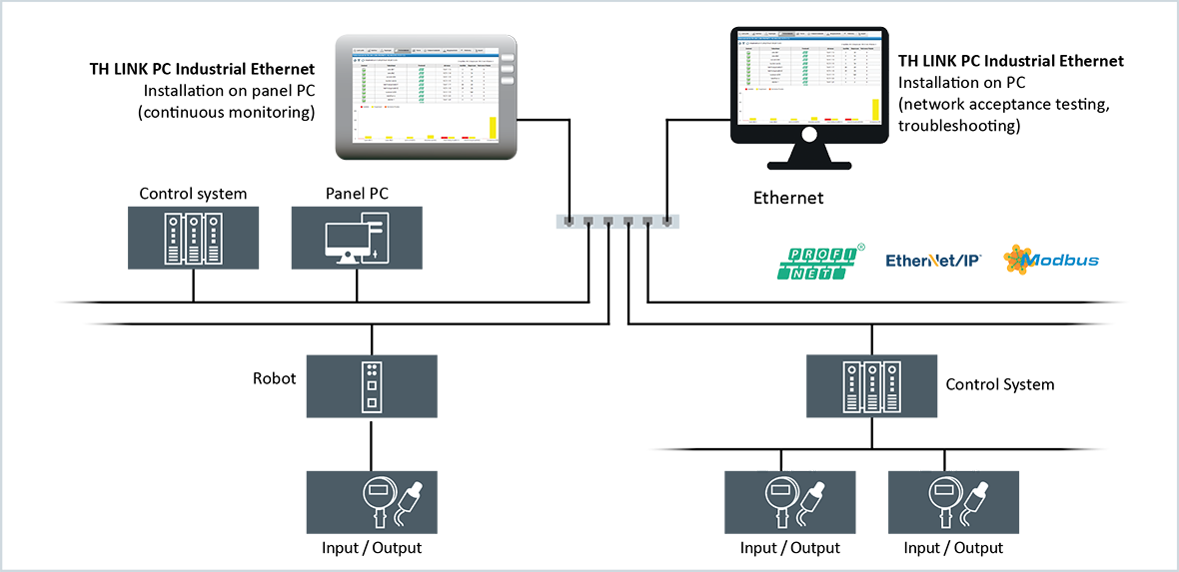

Describe the Modbus network, as used in a marine installation.
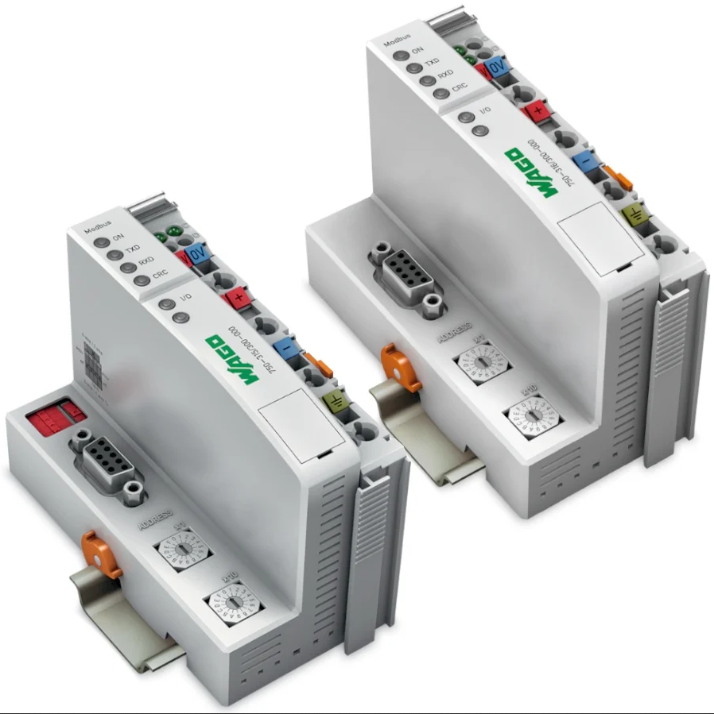
WAGO Modbus Couplers

Modbus is an open protocol, meaning that it's free for manufacturers to build into their equipment without having to pay royalties. It has become a standard communications protocol in industry, and is now the most commonly available means of connecting industrial electronic devices.
It is used widely by many manufacturers throughout many industries. Modbus is typically used to transmit signals from instrumentation and control devices back to a main controller or data gathering system, for example a system that measures temperature and humidity and communicates the results to a computer.
Modbus is often used to connect a supervisory computer with a remote terminal unit (RTU) in supervisory control and data acquisition (SCADA) systems. Versions of the Modbus protocol exist for serial lines (Modbus RTU and Modbus ASCII) and for Ethernet (Modbus TCP).

Explain the purpose, structure and functions of Voyage Data Recorder (VDR system)
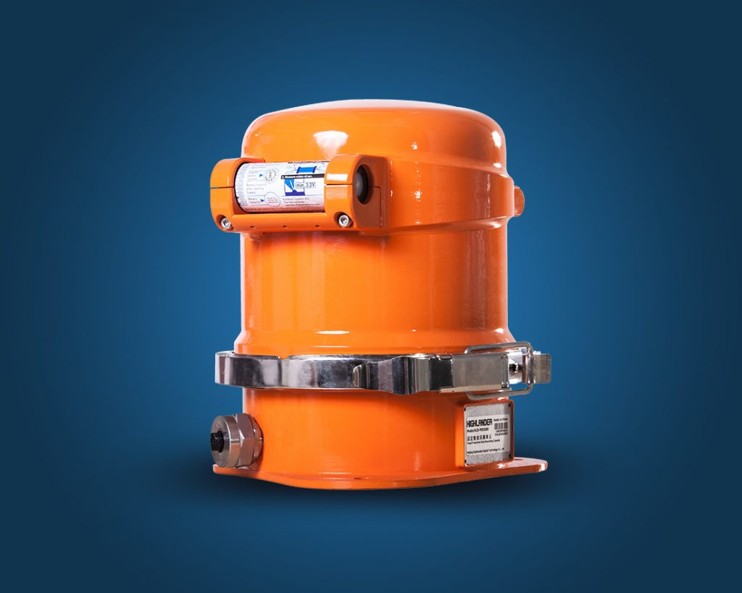

The Voyage Data Recorder (VDR) is a mandatory piece of equipment as required for foreign-going vessels under SOLAS requirements. It is typically a neon-orange fire-hydrant-looking unit mounted near the main mast or poop deck at the vessel’s highest point. This is so the VDR may be retrieved by a ROV or diver unit, if the ship was to capsize or sink.
Its primary function serves to assist in accident investigations by allowing investigators to review procedures, instructions and various vessel statistics prior to and following an accident.
Source: http://www.imo.org/en/OurWork/Safety/Navigation/Pages/VDR.aspx
The minimum requirements for a standard VDR are as follows:
- A waterproof housing in a float-free capsule
- Data Recording Unit (DRU) collating all relevant data
- Data Collection Unit, including back-up batteries and interface modules
The key functions of a VDR/S-VDR (Simplified VDR) are as follows:
Date and time (SVDR)
- Ship’s position (SVDR)
- Speed and heading (SVDR)
- Bridge audio (SVDR)
- Communication audio (radio) (SVDR)
- Radar data (SVDR)
- ECDIS data (SVDR)
- Echo sounder
- Main alarms
- Rudder order and response
- Hull opening (doors) status
- Watertight and fire door status
- Speed and acceleration
- Hull stresses
- Wind speed and direction
Source: https://www.marineinsight.com/guidelines/voyage-data-recorder-on-a-ship-explained/

Explain the purpose, structure and functions of Dynamic Positioning System
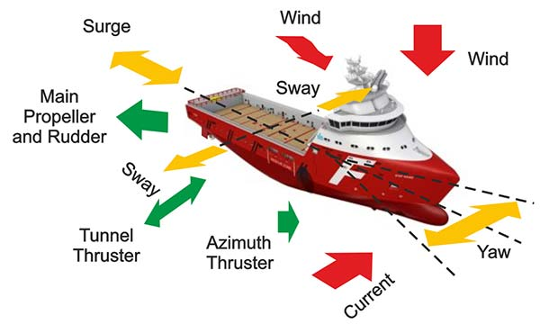
Managed Forces, and their relevant Components, and Unmanaged Forces in DP.
A ship has six degrees of freedom in its motion. These include:
- surge (forward/astern)
- sway (starboard/port)
- heave (up/down)
- roll (rotation about sway axis)
- pitch (rotation about heave axis)
- yaw (rotation about heading axis)
A DP system is focused primarily on motion on the horizontal plane (surge, sway, and yaw)
Dynamic Positioning systems can be broken up into two different categories, DP-X1 (direct) and DP-X2 (networked) as well as four classes (DP-[0-3]X).
Class Number | Description
Class 0 | Manual position control and automatic heading control
Class 1 | Automatic and manual position and heading control. No redundancy in systems means loss of position can occur in the event of a single fault.
Class 2 | Automatic and manual position and heading control. Loss of position should not occur from a single fault of an active component or system such as generators, thrusters, switchboards, remote control valves etc. However, loss of position can occur after failure of static components such as cables, pipes, manual valves etc.
Class 3 | Automatic and manual position and heading control. Loss of position should not occur from any single failure including a complete burn fire subdivision or flooded watertight compartments. Redundant and separated components.

Dynamic positioning systems are typically used by offshore vessels for accurate manoeuvring, for maintaining a fixed position or for track keeping (pipe/cable laying).
Dynamic Positioning is not always the best, or the most economical option. Mooring lines are usually a better option for shallow water, or for operation that does not require frequent relocation of the vessel. However, DP is certainly the best option for deep water operations; on congested sea-beds, and in situations where to vessel needs to relocated frequently.
Pros
- Quick and easy positioning and manoeuvrability of the vessel. No need for mooring lines, tug-boats and time-consuming anchor-handling operations
- Offshore operations can take place in ultra-deep waters were mooring lines are difficult to installed
- Little-to-no downtime between finishing or pausing a job to sailing away to avoid negative weather
- Very safe when working in congested sea-beds with many pipelines, mooring lines from other vessels or subsea structures such as manifolds, well-heads, risers etc.
Cons
- High capital expenditure for designing and installing a DP system
- High fuel consumption and increased maintenance cost, increased operating costs.
- It poses limitations in very shallow waters and situations were diving operations must take place close to the thrusters
- Potentially severe consequences in case of equipment failure during pipe-laying or during operations near fixed platforms, without the proper level of redundancy
A DP system typically uses several reference systems to accurate determine the vessel's location in real-time. These include:
- DGPS and GPS Systems
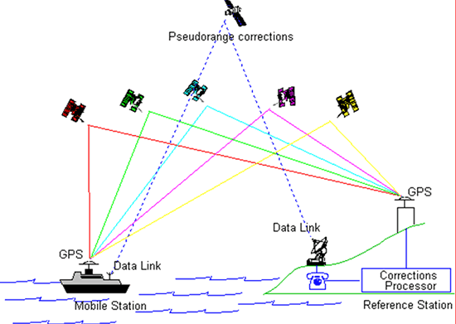
Differential GPS makes use of fixed ground-based installation in addition to traditional satellite GPS systems to provide extremely accurate positional information. Both DGPS and GPS services usually require a subscription fee from the provider companies.
- Acoustics
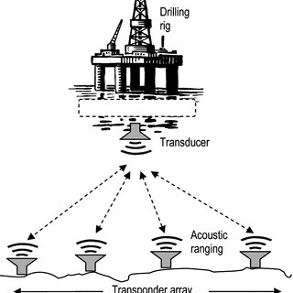
By making use of sound waves to communicate with one or more transponders on the sea bed in conjunction with a transducer on the ship's hull. A sound profile is taken regularly, to determine the velocity of the sound within the water, and distance is measured using velocity and time.
- Taut wire
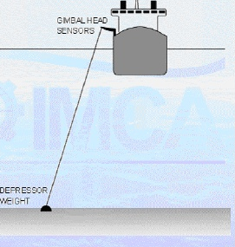
An older system, but still viable, uses a gimbal mounted weight on a stainless steel wire which is lowered to the sea bed, and the gimbal mount uses potentiometers similar to a joystick to determine the location of the ship in relation to the weight.
- Fanbeam/CyScan
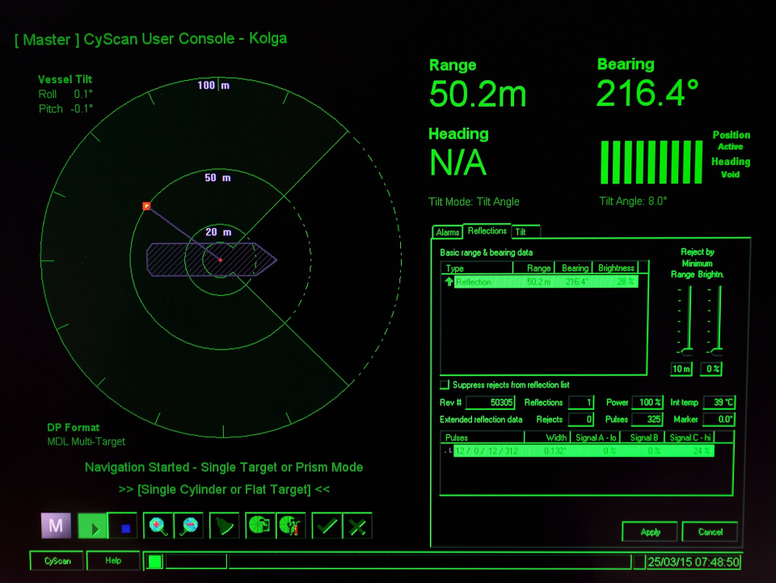
Laser based reference systems, which fire an infrared laser at a prism cluster mounted on a fixed known location, such as a oil rig.

- Artemis
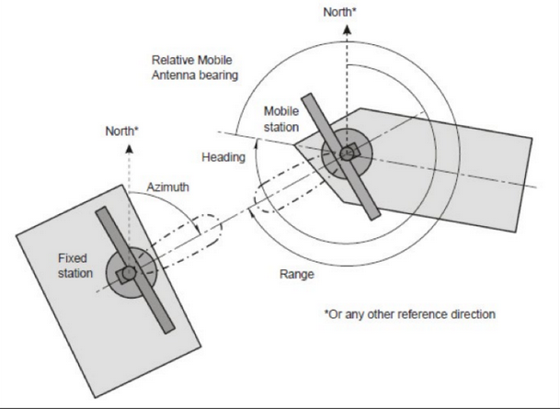

Less commonly used, but uses radar waves to determine location in relation to a fixed reflector.
- RADius
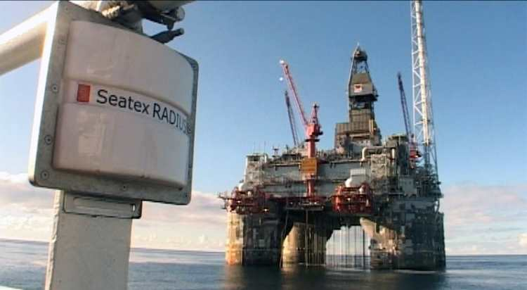
Generally replaces Artemis. Less effective range (600m instead of 4km) but multiple known active points can be used to improve the DP system's situational awareness.
- Gyrocompasses
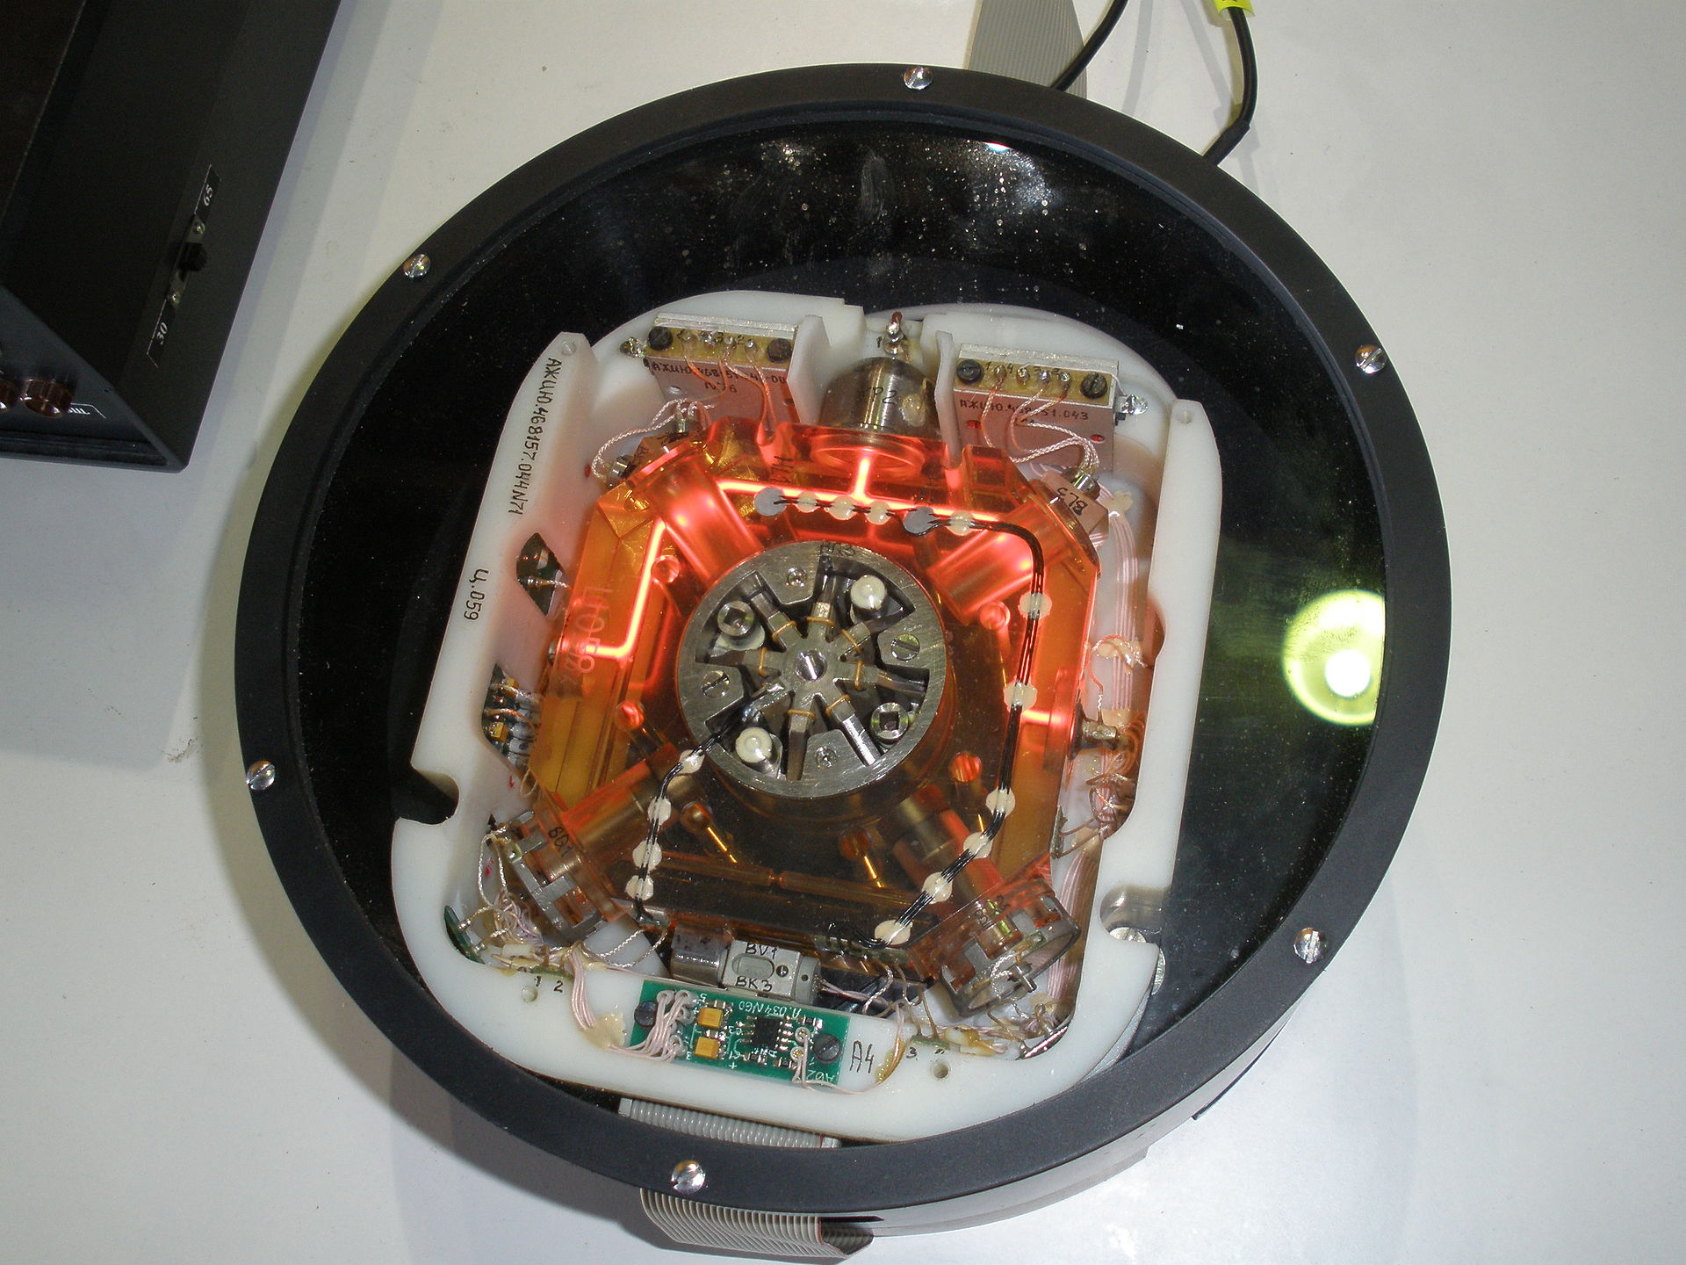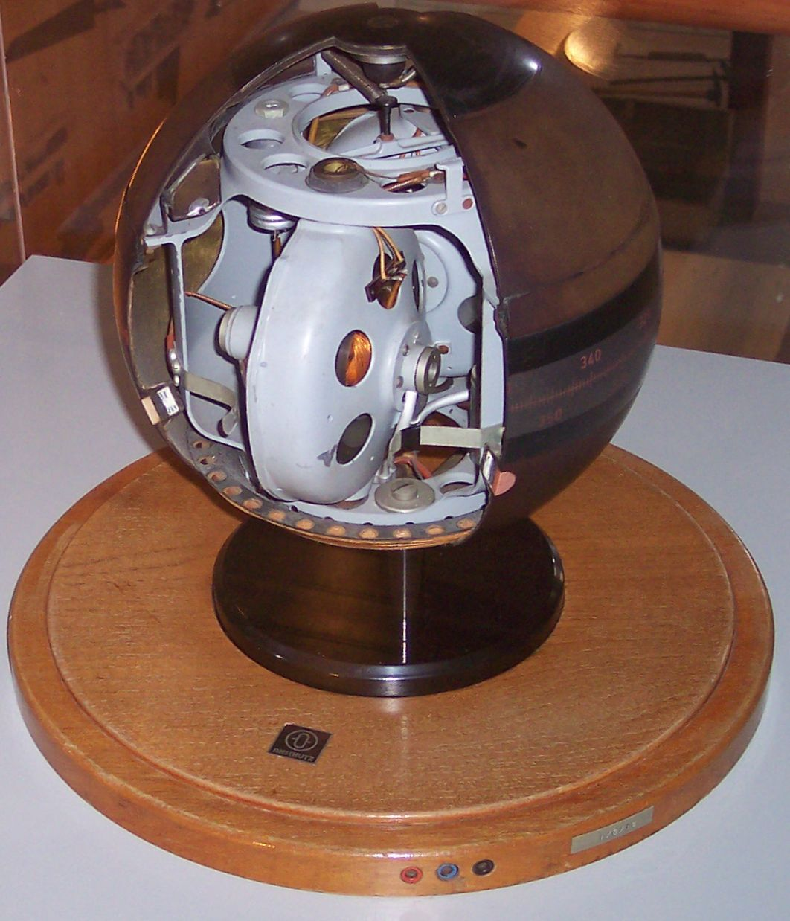
Either a solid-state (Ring laser) gyrocompass or the traditional spinning disk-type determines the vessel's true heading.
Sensors are also employed in a DP system to build a predictive model on the vessel's movement using a Kalman filter:
- Motion Reference Units (MRUs)
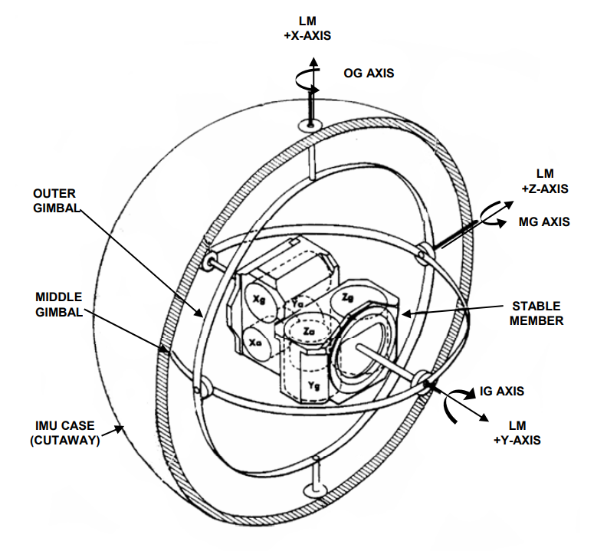
Used to determine the ship's roll, pitch and heave.
- Wind sensor
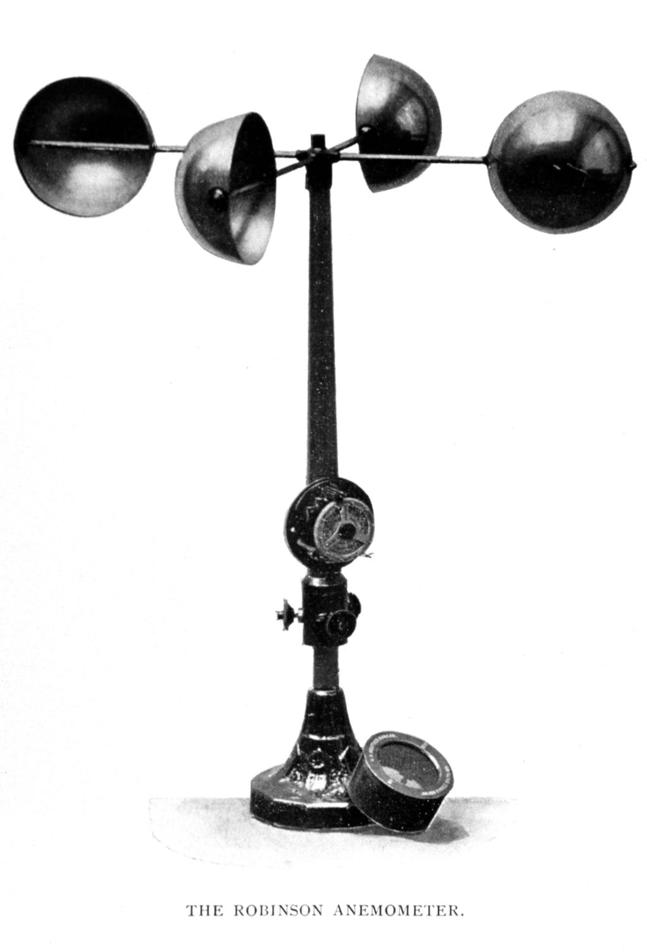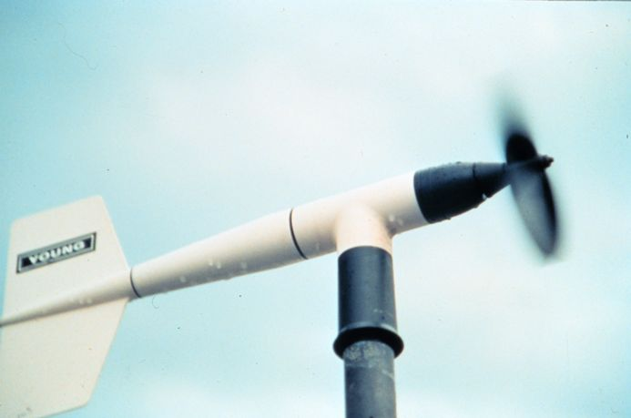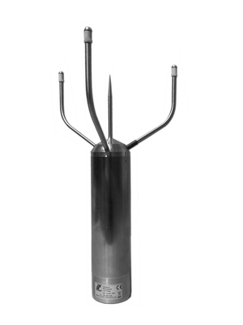
Anemometers vane or cup, or solid-state ultrasonic units determine the velocity and direction of the wind.
- Draught sensor
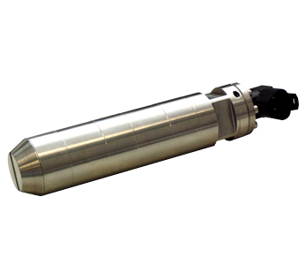
Used to measure the vessel's current draught. A pressure/level sensor.
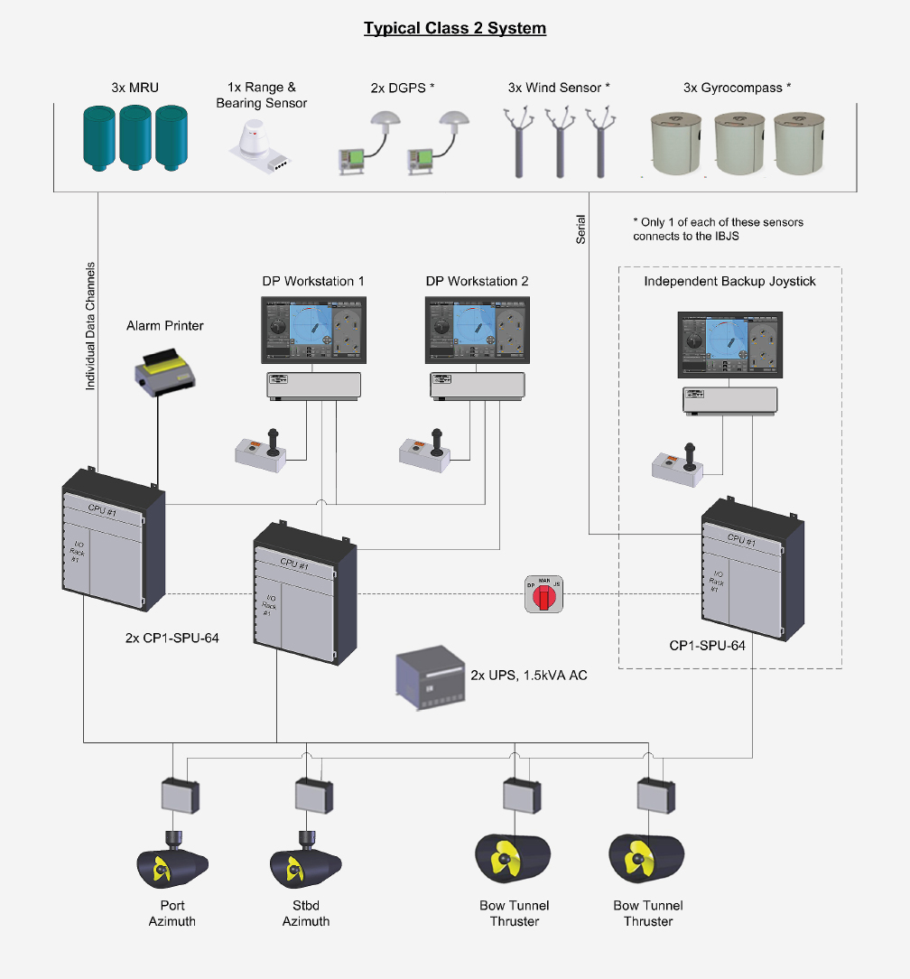

Explain the purpose, construction and operation of vessel fuel consumption optimizing systems (for example NAPA, ENIRAM)

The shipping industry continues to face pressure from a variety of different sources. Measures like the MRV directive are steering companies to adopt new technologies to ensure compliance. Meanwhile, there is a continued need to improve efficiency in a highly competitive market suffering from overcapacity.
Digitalization and connectivity are seen as part of the solution to these problems. The consensus is that data needs to be collected – the problem is that validation and filtering of this data is missing. The end result is vast quantities of information that is of little or no practical use.
Better situational awareness enables a top-down, fleet-wide approach to improving energy efficiency, with an easy to understand and digest dashboard, overviewing an entire fleet's fuel consumption and their performance key performance indicators (KPIs) allows operators and management to better harmonize vessel performance statistics and plot routes that are more cost-effective and energy efficient.
With the shipboard environment becoming increasingly complicated, it’s no longer enough to just optimize the engines, trim, or route in isolation. Instead, operators need to look at their vessel as a whole to find the most efficient combinations for all onboard variables, along with weather, sea state, and other factors.
Voyage efficiency software collates power consumption data and navigational data, along with real-time fuel capacity and vessel velocity/heading and forecast information to present instantaneous RPM, trim, engine configurations and route recommendations to navigational officers to maximize fuel efficiency in a way which learns, adapts and improves over-time.

Explain the purpose, structure and functions of PLC or PC based power management systems

Automation in the marine industry is becoming a critical tool to streamline crew workloads and reduce repetitive tasks better suited to logic devices, such as a PLC.
By allowing a logic device to control the power systems of a vessel while at-sea, crew can focus more on oversight and preventative maintenance, rather than hands-on control of subsystems.
Naturally, these controls will still be able to override any individual logic command, or be completely disabled entirely, if a fault or otherwise unknown factor is introduced which the logic device has no situational awareness of.
Manual control can be further made unnecessary, however, with the addition of pre-programmable vessel 'states' such as "sea mode", "port mode", "manoeuvring mode" which use a predefined array of settings, for example, "manoeuvring mode" will most likely start every available generator, synchronize and close their breakers, and then bring all controllable pitch propellers to 0 degrees pitch and start them for dynamic positioning or navigational officer control.

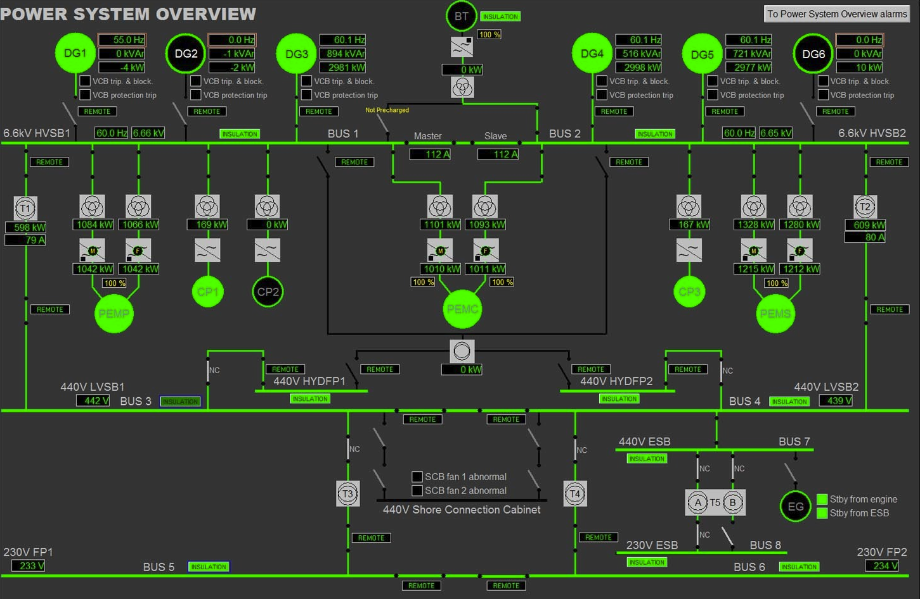
Overview of a PC-controlled power sytem.

Explain the purpose, structure and functions of Electronic Alarm Recorder (for example Prilog)

Electronic recording of logs reduces operating costs by eliminating wasteful paper usage, as well as reducing administrative burden, and allows alarms & data about alarms to be easily categorized and visualized.
Before replacing a hardcopy record book, the electronic record book (ERB) will be subject to approval by the Flag State. A set of guidelines for the use of ERBs under MARPOL has been developed by the IMO providing standardized information on approving ERBs. This is to ensure that the obligations of MARPOL are met and that there is a consistent approach to approving such systems.
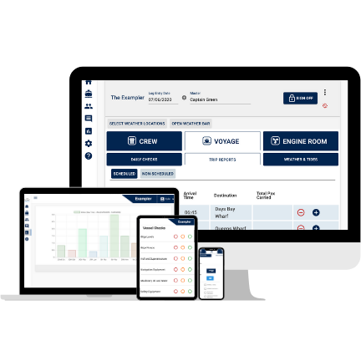
The SeaLog series of ERBs are available on multiple devices, for ease of use.
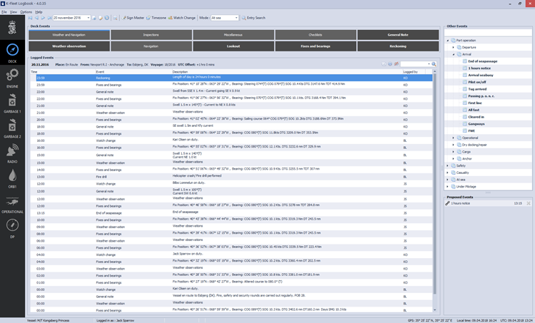
K-Fleet Logbook has an intuitive user interface for data aggregation.
By also having frequent off-site data backups, it enables superintendents and head offices to see a near real-time list of alarms which further increases their ability to produce effective long-term maintenance plans by identifying issues potentially before they become critical.
Key advantages in the ERB system include:
- Software system collects data from ship systems into one single data storage manually or automatically.
- Supports event based recording of data related to navigation, engine, garbage handling, port calls and other operational activities.
- Supports data exchange for events that shall be recorded in multiple logbooks.
- Auto Values reads Tags and values automatically from an external source making the daily reporting tasks less time consuming.
- Easy access to previous recorded events of same type.
- The customer can define rules for proposed events, for reminding the operator of required log entries.
- Configurable drop down menus and adjustable default values for each input field.
- Periodical and emergency backup of data.
- Security features like user identification, password protection, traceability of entries, and database encryption.
Source: https://www.kongsberg.com/globalassets/maritime/documents/401849_k-fleet_logbook.pdf

Explain the purpose, structure and functions of Computer Systems for critical equipment condition monitoring (for example METALSCAN, SWANTECH)

Owners, operators, and maintainers of critical equipment need reliable and timely information on the condition of their equipment to avoid unplanned shutdowns and maximize the productivity of these important assets.
By incorporating a non-invasive always-online debris sensor into lube oil networks, for example, serious failures can potentially be avoided with careful maintenance planning.
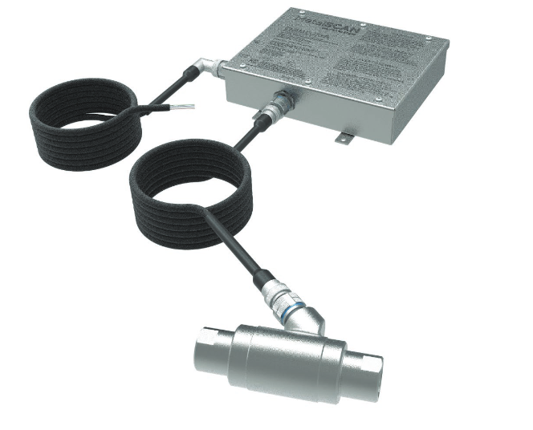
Gears and bearings are particularly at risk for extended periods of high load, and products like MetalSCAN assist in determining their condition.
The Sensors are a durable stainless-steel assembly engineered to be installed directly onto fluid lines. The recommended location for the Sensor is on the lubricant common scavenge line directly downstream of the wear elements.
There must be no debris traps or filters between the Sensor and the oil wetted components being monitored. The Sensors are designed to operate in severe industrial and/or hazardous environments with large temperature extremes and high vibration levels.
The sensing element consists of three internal coils. The two outside field coils are oppositely wound and are driven by an alternating current source so that their respective magnetic fields are opposed and cancel at the center point between the field coils.
The centrally positioned sense coil measures the disturbances in the magnetic fields caused by metallic particles as they pass through the Sensor. The magnitude of the disturbance measured as a voltage defines the size of the particle and the phase shift of the signal defines whether the metallic particle is iron-based (ferromagnetic) or otherwise.
In addition to the sensor unit, the Electronic Control Unit (ECU) houses the system electronics that are essential in processing the disturbances measured by the Sensor. The corrosion resistant stainless-steel enclosure is designed for back side mounting on a bulkhead or plate with all interconnecting cables entering through the bottom and sides of the unit.
The Sensors are electrically connected to the Electronic Control Unit (ECU) using a high temperature, low noise shielded cable designed specifically for severe industrial and hazardous environments. This cable makes the connection between the Sensor and ECU mounted on a bulkhead or plate. The inductive coils of the Sensor assembly are designed to achieve maximum sensitivity to particles present in the lubrication fluids. The sensor cable and connectors play a significant part in achieving the level of sensitivity necessary for the system to operate properly.
Connection of the Electronic Control Unit (ECU) to both a nominal 24 VDC power source and serial communications (Modbus RTU, RS485) to the host PC or Engine Controller is achieved via a dual power/comms cable.
Source: https://www.gastops.com/wp-content/uploads/2020/05/c010024-ms4110-brochure.pdf

